Name: Wakeland Branz

Date: 09/26/2023

\*\*Module Four AP Classroom Assignment One\*\*

1. Open the College Board AP Classroom and complete the following tasks:

2. In Unit 1 Topic 1: Why Programming? Why Java? (30 points)

- Watch 1.1: Daily Video 2 (Skill 2.B)

- In a Word doc, complete a 3-2-1:

\* 3 Things I knew

1. The compiler will ignore anything after // in the same line or between /\* and \*/ characters
2. There must be a main method in every class
3. System.out displays output to the console

\* 2 Things I learned

1. System.out.println uses the \n operator
2. System.out.print keeps the cursor on the same line

\* 1 Thing I still question

* How can I import classes from separate java files into one another?

3. In Unit 1 Topic 2: Variables and Data Types (35 points)

- Watch 1.2: Daily Video 2 (Skill 1.B)

- In your Word doc, answer the following in complete sentences:

\* What was the definition she gave for a variable? Must be exact for full points.

A variable is a name given to a memory location that is holding a specified type of value.

\* How did she know that the variable in the code was a constant?

The Java reserved world final was ahead of the declaration.

\* What was the video's take away?

The video’s take away was proper ways to declare variables of the correct types to represent primitive data.

4. In Unit 1 Topic 4: Compound Assignment Operators (35 points)

- Watch the following videos:

\* 1.4: Daily Video 1 (Skill 2.B)

\* 1.4: Daily Video 3 (Skill 5.A)

- In your Word doc, answer:

\* According to the two videos, what is the difference between tracing the code and describing the code? Give an example using the same sample code of your choice.

Sample code:

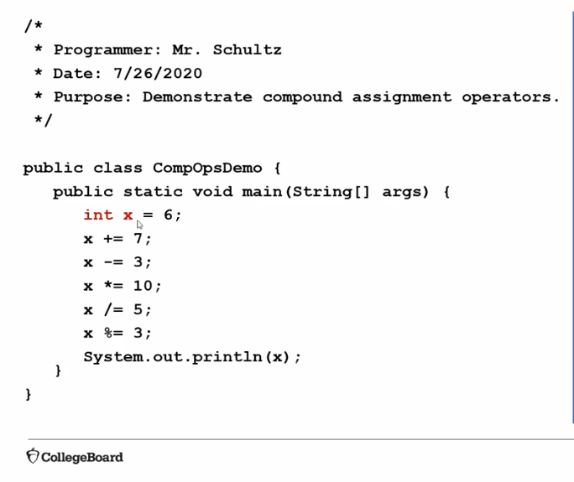

Tracing code by hand allows you to step through each individual step of code, showing how the code is executed to yield its result. Describing code merely explains what each line does without showing what it yields, giving the user a general idea of what is happening throughout the code but requiring them to investigate the code themselves to understand it.

5. Select Unit 1 Personal Progress Check MCQ Part A.

- Answer all the questions to the best of your ability.

- Click Submit to record answers.

6. Save your Word doc and submit below.